# **Deploying Linux Cluster**

This demo is for creating a Linux cluster in azure portal.

**Creating HDInsight and Configuring Linux Cluster:**

Go to **+ Create Resource -> Analytics -> HDInsight**.

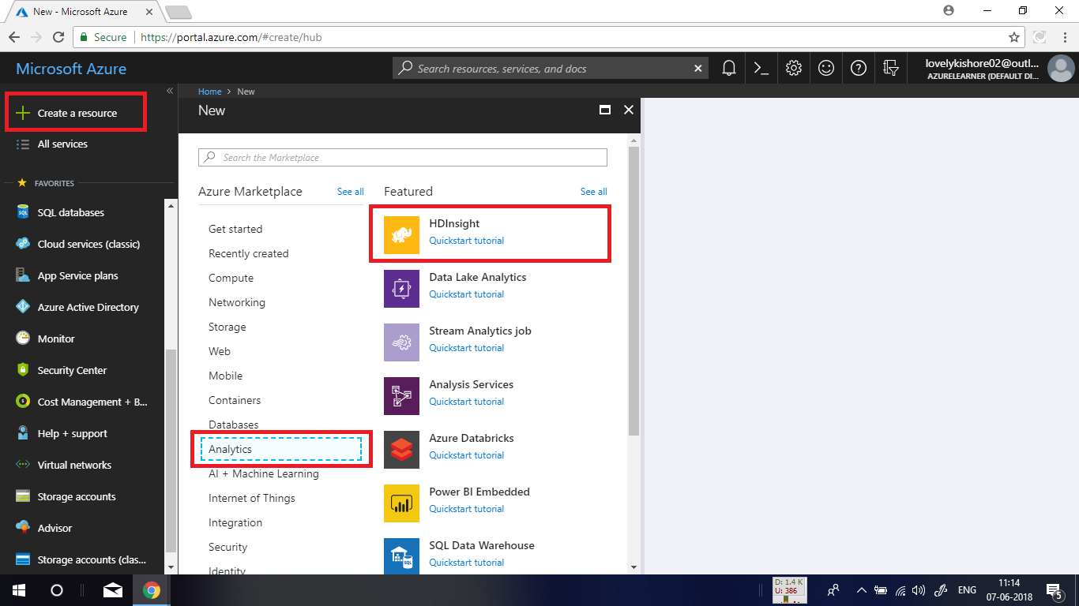

In the basic settings blade, give a name for **cluster.** In the cluster type, choose **Hadoop** from the drop-down list, operating system as Linux and select latest version of it and click on **Select** button. Give an **Username** and **Password.** Choose a resource group and click on **Next.**

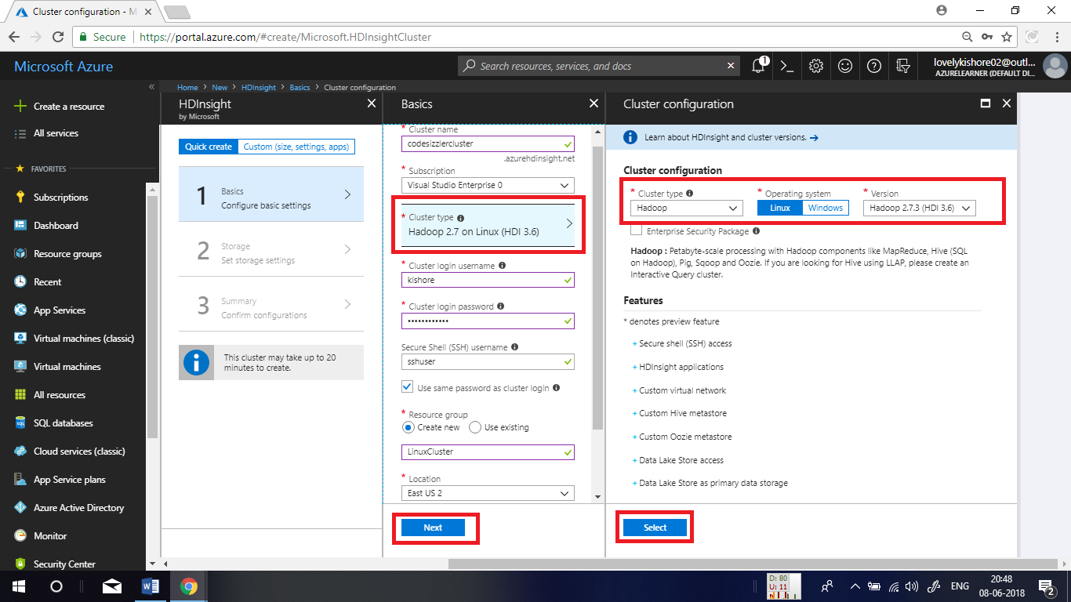

In the storage settings blade, choose **Primary Storage Type** as **Azure Storage** and **Selection Method** as **My Subscriptions.** Choose an existing storage account or create new by giving an unique name for it. Let the container name be default in there. Leave all other settings as default and click on **Next** button.

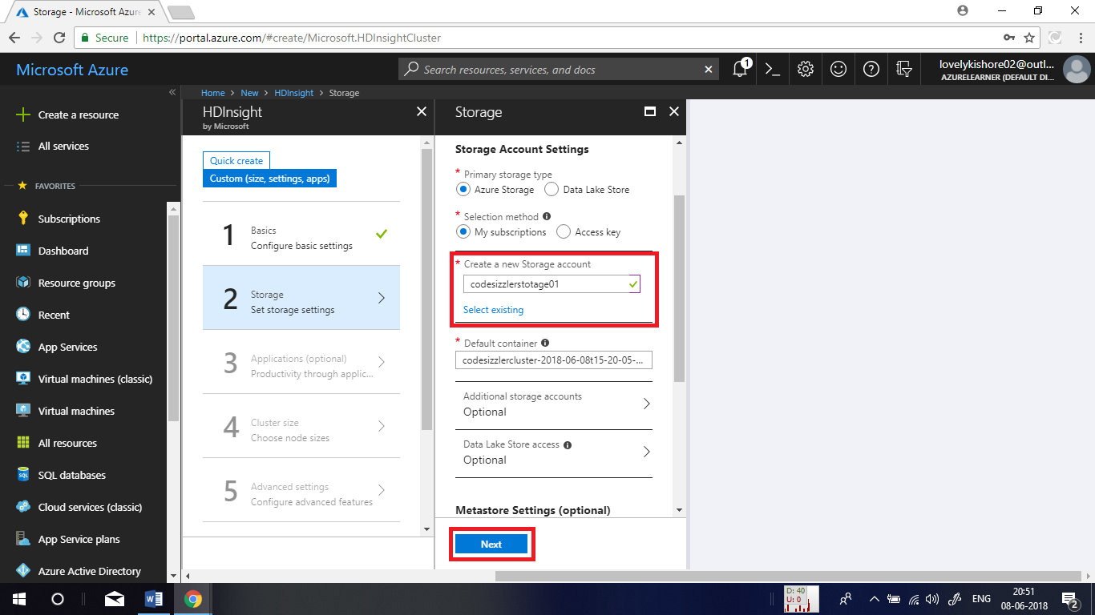

Don’t add any applications. Skip this by clicking on **Next** button.

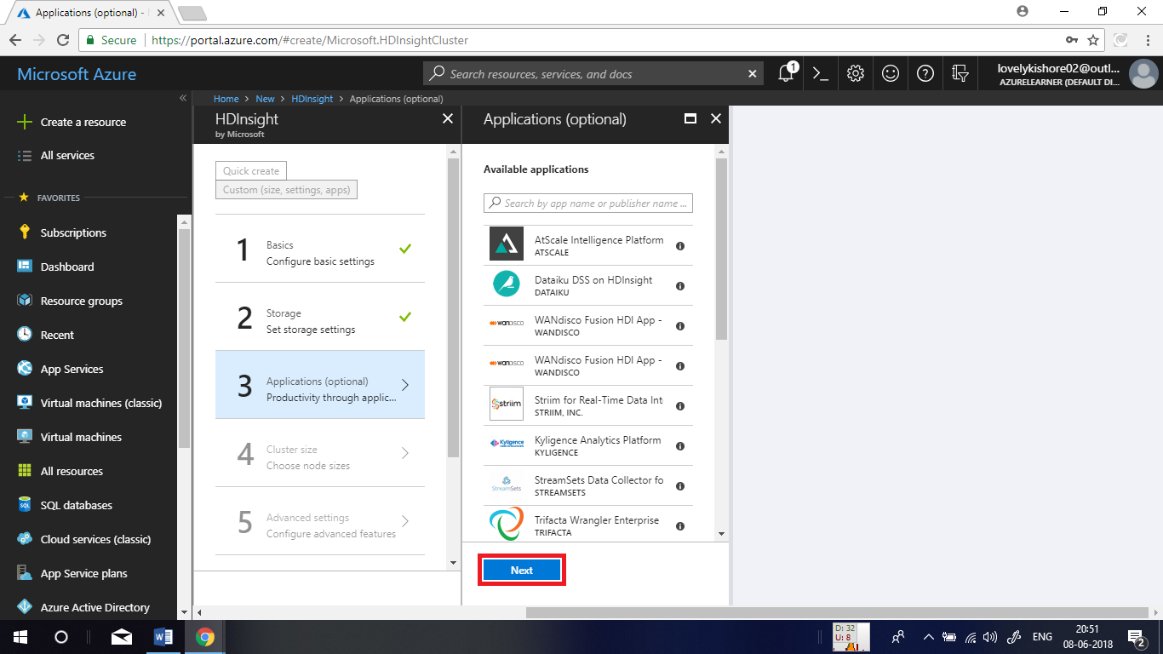

Leave the cluster size and advanced settings as default and click on Next button and at last in the summary page click on create button.

